**Explanation datasets**

**Nests_useful**

Datasheet with nest-related information.

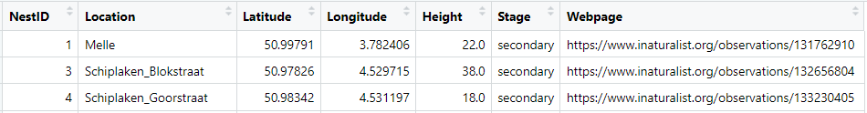

**NestID:** Unique number for every nest.

**Location:** City of the nest (if multiple nests in one city: ‘_street’ added).

**Latitude:** Latitude in WGS84 Reference System.

**Longitude:** Longitude in WGS84 Reference System.

**Height:** Height of the nest (source: extermination reports of VBI).

**Stage:** Stage of the nest (primary – secondary – tertiary).

**Webpage:** Link to the observation page on iNaturalist.org.

**Baits_useful**

Datasheet with bait-related information.

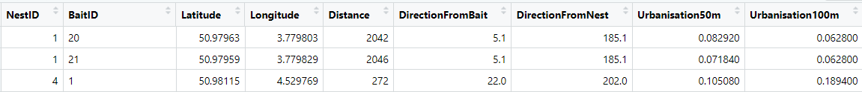

**NestID:** NestID from datasheet ‘Nests_useful’ to which the bait is linked.

**BaitID:** Unique number or name for every bait.

**Latitude:** Latitude of the bait location in WGS84 Reference System.

**Longitude:** Longitude of the bait location in WGS84 Reference System.

**Distance:** Distance from the bait to its related nest.

**DirectionFromBait:** The angle between a vertical line pointing to the North (N=0°) and the line connecting the bait and its nest, measured from the bait. (Purple angle). This is the angle we are finally going to use in the analyses.

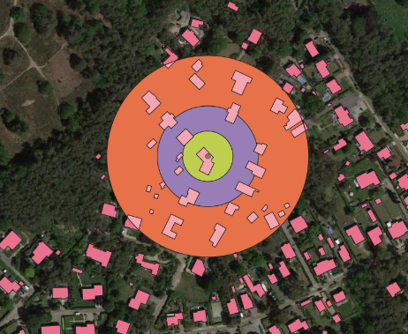**DirectionFromNest:** The angle between a vertical line pointing to the North (N=0°) and the line connecting the bait and its nest, measured from the nest. (Red angle)

**Urbanisation50m:** Percentage of buildings in a radius of 50m around the bait (Purple circle). The building information was retrieved from geopunt.be. The Gbg (grounded building) map layer from the GRBgis file (basic map of Flanders) contained polygons of all buildings in Flanders.

**Urbanisation100m:** Percentage of buildings in a radius of 100m around the bait. (Red circle)

**Urbanisation25m:** Percentage of buildings in a radius of 25m around the bait. (Green circle)

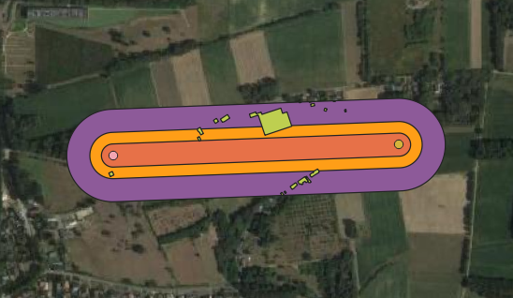**Traject100m: :** Percentage of buildings in a radius of 100m around the line connecting the bait and the nest. So, the width is 200m in total. (Purple shape)

**Traject50m:** Percentage of buildings in a radius of 50m around the line connecting the bait and the nest. So, the width is 100m in total. (Orange shape)

**Traject25m:** Percentage of buildings in a radius of 25m around the line connecting the bait and the nest. So, the width is 50m in total. (Red shape)

**Urbanisation:** categorical value for urbanisation, existing of three levels, being landelijk, randstedelijk, verstedelijkt.

**Urbanisation_EN:** Same as Urbanisation but English version.

**Individuals**

Datasheet with individual-related information.

**NestID:** NestID from datasheet ‘Nests’ from which the individual originated.

**BaitID:** BaitID from datasheet ‘Baits’ on which the individual was foraging.

**ColorInd:** Unique color/number for each individual on each bait.

**Weight_jar_ind:** The weight of the jar with the individual in it (g).

**Weight_jar:** The weight of the jar after releasing the individual (g).

**Weight_ind:** The weight of the individual (g): Weight_jar_ind – Weight_jar.

**Flights_all**

Datasheet with information related to every flight time measurement. This, for all the data points and my own weather measurements.

**NestID:** NestID from datasheet ‘Nests’ from which the individual originated.

**BaitID:** BaitID from datasheet ‘Baits’ on which the individual was foraging.

**ColorInd:** ColorInd from datasheet ‘Individuals’.

**ID:** Unique number for each flight.

**Date:** Date the flight was measured.

**Time:** Time the flight was measured.

**Observer:** Unique letter for each observer. (‘A’ being myself, all other observers are volunteers)

**Distance:** Distance from the bait to its related nest.

**DirectionToNest:** Same as *DirectionFromBait* in ‘Baits_useful’

**Flightdirection:** Direction (°) the hornet was flying away from the bait (North=0°).

**FlightError:** The difference (°) between the flight direction from the bait and the actual direction to the nest (Flightdirection – DirectionToNest).

**Flighttime:** The time measured (h:min:s) from the moment the hornet left the bait, flying to its nest, till the hornet came back to the same bait.

**Flighttime_min:** Flighttime in minutes.

**Cloudcoverage:** Percentage of clouds present at the moment of measurement. (0 no clouds, 1 completely cloudy)

**Rain:** Number from 0 to 4, explaining the precipitation levels. (0=no rain; 1=drizzle; 2= light rain; 3= average rain; 4=hard rain/storm)

**Windspeed:** Windspeed (m/s) present at the moment of measurement.

**Winddirection:** Wind direction (°) at the moment of measurement.

**Temperature:** Temperature (°C) at the moment of measurement.

**Winddifference_flightdirection:** The angle (°) between the Flightdirection and Winddirection.

**Wind_flight:** Categorical variable describing the wind direction relative to the flight direction of the hornet. Following formulas are applied:

Winddifference ≤ 45° is *tailwind*

45° < Winddifference <135° is (quasi) *perpendicular*

Winddifference ≥ 135° *upwind*

**Winddifference_nestdirection:** The angle (°) between the DirectionToNest and Winddirection.

**Wind_nest:** Categorical variable describing the wind direction relative to the direction to the nest from the bait.

**Flights_shortind**

Same as Flights_all but contains only the shortest flight of each individual per bait.

**Flight_KMI**

Same as Flights_all but contains weather measurements of KMI.

After dataset adjustments (which can be found in Dataset_aanpasingen.rmd) the following DEFINITIVE datasets were created and used for the analyses.

**Eigendata**

Flights_all but the useful variables of ‘Nests_useful’, ‘Baits_useful’, and ‘Individuals’ added:

Nest related information added: Height

Bait related information added: Distance, DirectionToNest, Urbanisation25m, Urbanisation50m, Urbanisation100m, Traject25m, Traject50m, Traject100m, Urbanisation, Urbanisation_EN

Individual related information added: Weight_ind

And the variables below:

**test_rule_of_thumb:** The speed (m/s) of the foraging process (Distance/Flighttime_min)

**ForagingSpeed:** The speed (m/s) the hornet was flying. (Distance*2/Flighttime_min)

**Eigendata_shortind**

Same variables as Eigendata but contains only the shortest flight of each individual per bait.

**KMIdata**

Same variables as Eigendata but contains weather measurements of KMI.